Part I:

- Build the following network in miniedit and save it for use in mininet.

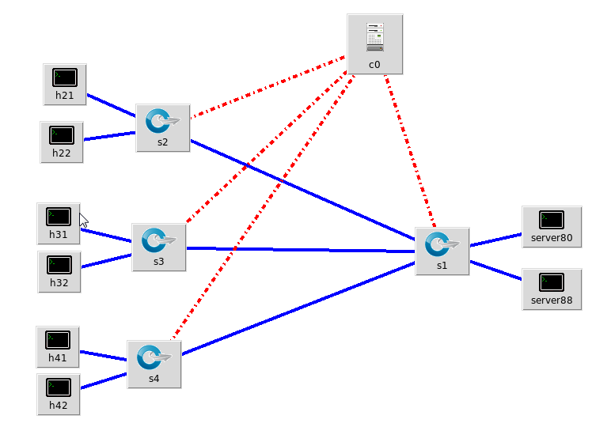

Hosts hxy: 10.10.x.y
Server80: 10.10.1.100 python –m SimpleHTTPServer 80
Server88: 10.10.1.200 python –m SimpleHTTPServer 88
Switches: sx : dpid=x
Controller: remote

- Copy forwarding.l2_learning to ext/l3_fw.py
- Modify the l3_fw.py to permanently block http:80 connections from subnet 10.10.3.x/24 to 10.10.1.x/24 on s1

- Test the rule using curl command (curl –o -- http://<ip>:<port>) from all hosts to all servers.

- Include snapshots of curl response to both servers from each host and show that only the source/destination pairs defined above are blocked.
- Modify the l3_fw.py to give an idle timeout of 60seconds to the rule and update the rule upon arrival of PacketIn messages on s1 (i.e., new PacketIn messages trigger the blockage). May need to assign higher priority to be checked before l2_learning or just add the check before those checks.
- Test the operation by first running a curl from h31 to 10.10.1.100 during the first 60 seconds, then another one after the 60 seconds. Then issue a curl command from h42 to 10.10.1.200 and after that try the h31 connection again.
- Include all your files in a clear manner in a zip file so that they can be evaluated.

Part II:

- Expand the above network to have 3 servers all running web server on port 80.
- Copy the ip_loadbalancer.py controller to your ext folder as ents_loadbalancer.py.
- Modify the code so that it divides the load among the 3 servers in a deterministic and weighted manner with Sx having weight x. This means for every 6 consecutive requests arriving at the load balancer, the first one goes to S1, second and third to S2, and 4th/5th/6th go to S3.
- Initiate curl requests from h11 in a loop with a 2sec delay between each request from a batch file like below (with your own url and sleep value):
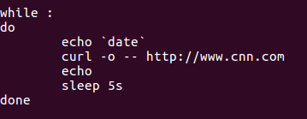
You need to run “chmod uog+x filename” to make the file executable.
- Capture the http traffic or TCP SYN or any other measurement in wireshark and show the correct assignment of requests to servers over a period of at least 12 http requests.
- Include all your files in a clear manner in a zip file so that they can be evaluated.

